Sponsored by Total Transition Services
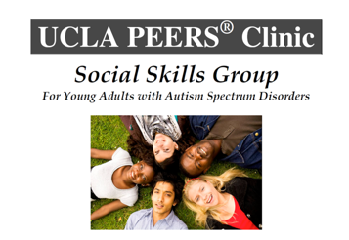
Topics of instruction include:
Conversation Skills, Dating Skills, Appropriate Use of Humor, Electronic Communication,
Entering and Exiting Conversations, Handling Teasing, Bullying, Gossip,
Arguments and Disagreements with Peers, and having appropriate Get-Togethers with Friends

For more Information Contact:
Marcey Chapman at 254-733-2985 or m.chapman@yourtts.com
This is an Evidence-based, caregiver-assisted social skills intervention for young adults with:
Autism Spectrum Disorder, ADHD, Anxiety, Depression, and other social and behavioral problems

